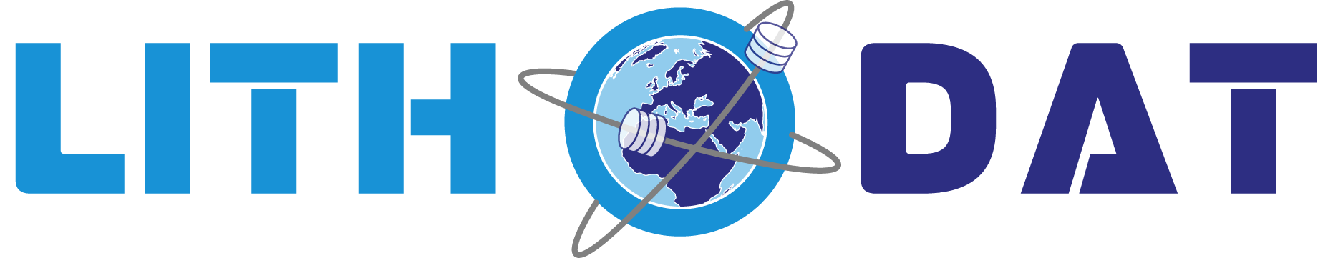

Isotopes.au Project Summary
Federal National Stable Isotope Platform – Multi-Agency Scientific Data Integration



GDAC-SA Advanced Analytics Platform RFQ
Lithodat Pty Ltd
ABN: 63 627 008 904

Project Overview: is Australia's first national digital platform for standardizing, integrating, and querying stable isotope laboratory data across federal agencies and research institutions. Officially launched by CSIRO on February 18, 2025, the platform consolidates isotopic data—food's unique chemical fingerprints—into a single, open-access, trusted resource for verifying food provenance and sustainability claims.

1. Overview
Developed by Lithodat Pty Ltd in partnership with CSIRO, ANSTO, Geoscience Australia, NMI, and ARDC, Isotopes.au demonstrates advanced capability in multi-agency data harmonization, unified schema design, and FAIR-compliant scientific repository construction. The platform integrates six institutional data sources across three federal agencies, providing critical infrastructure for Australia's $80 billion agriculture and food export industry.
Platform Access: Explore Isotopes.au at https://app.isotopes.au

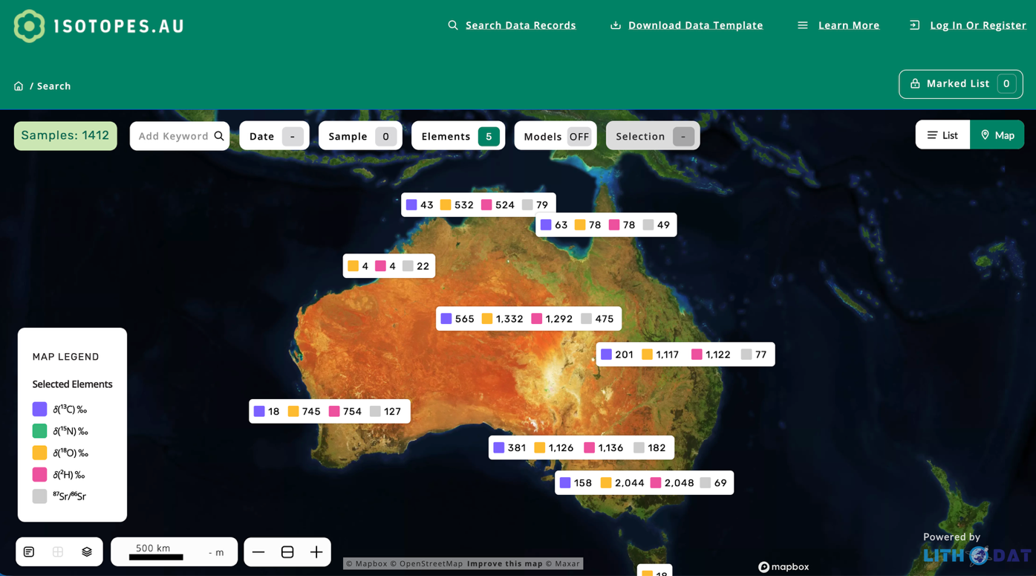
Figure 1: Isotopes.au platform interface showing interactive map-based data access and filtering capabilities for stable isotope measurements across Australia.

2. History & Funding
Contract Value: $400,000 AUD
Duration: May 2023 – December 2025 (ongoing hosting and support) | Program expansion through 2028
Funding Sources: Australian Research Data Commons (ARDC) + CSIRO co-funding
Performance Rating: Excellent (5/5) – 100% successful delivery
Lithodat delivered the complete platform on time and within budget, extending the LithoSurfer infrastructure to support isotope-specific data models. The project achieved all technical milestones, including integration of six institutional data sources, development of a 250+ field ontology with 97% match rate, and implementation of hybrid automated/manual ingestion workflows.
The contract renewal for ongoing hosting and support through 2025, combined with program expansion to 2028, demonstrates exceptional client satisfaction. CSIRO Lead Scientist Dr. Nina Welti is available as a reference contact (nina.welti@csiro.au) to verify project performance and technical excellence.

3. Key Collaborators
Isotopes.au represents a successful multi-agency federal collaboration across five major Australian government organizations:
CSIRO (Project Lead): Environmental isotopes laboratory data from two institutional sources (LabData and Data Access Portal), plus overall scientific direction and platform governance.
ANSTO (Australian Nuclear Science and Technology Organisation): Isoscape datasets and GNIP (Global Network of Isotopes in Precipitation) data, providing critical precipitation isotope measurements across Australia.
Geoscience Australia: National isotope surveys and hydrochemistry datasets from two institutional sources, contributing geological and hydrological isotope measurements.
NMI (National Measurement Institute): Isotope measurement standards and calibration data, ensuring measurement accuracy and consistency.
ARDC (Australian Research Data Commons): Infrastructure co-funding partner supporting national data infrastructure development.
"Customers increasingly want to know where and how their food was sourced so they can make ethical and more sustainable choices. This is just the beginning of capturing Australia's wealth of isotopic data into one place—Isotopes.au—to help industries demonstrate how they're meeting environmental targets for greater transparency with trading partners and consumers."
— Dr. Nina Welti, CSIRO Lead Scientist

4. Platform Capabilities
Isotopes.au integrates six institutional data sources through custom-developed adapters, harmonizing diverse data formats, measurement units, and metadata structures into a unified national data model. The platform achieved a 97% ontology match rate across 250+ standardized field mappings after three iterative refinement rounds, demonstrating robust schema design.
Supported isotope systems include stable isotopes (δ¹³C, δ¹⁸O, δ²H, δ¹⁵N), radiogenic isotopes (⁸⁷Sr/⁸⁶Sr, Nd, Pb), and δ³⁴S for mineral deposit studies. The platform handles complex isotopic measurements with full procedural metadata, quality control flags, and measurement uncertainties.
Hybrid ingestion architecture combines automated adapters for structured institutional data with a semi-automated import wizard for legacy and irregular datasets. The import wizard achieved 93-96% field mapping accuracy with rejection rates under 6% after QA validation, completing most imports in under 15 minutes.
API-first design provides RESTful web services with comprehensive Swagger documentation, enabling programmatic access for analytics tools, external system integration, and automated workflows. The platform features interactive MapBox-powered geospatial visualization with GeoJSON rendering, filtering by isotope type, measurement method, material type, geographic region, and date range.
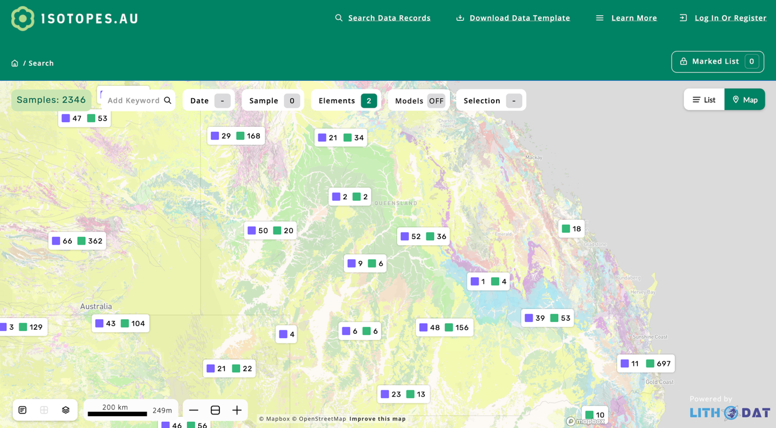
Figure 2: Platform data visualization capabilities demonstrating geospatial mapping, isotope measurement display, and metadata filtering across multiple institutional data sources.

5. FAIR Data & Impact
Isotopes.au implements comprehensive FAIR data principles (Findable, Accessible, Interoperable, Reusable) with persistent identifiers (DOI, IGSN), rich metadata using controlled vocabularies, open API access, and standardized data formats (JSON, GeoJSON, CSV). The LithoSurfer platform achieved CoreTrustSeal certification for the AusGeochem portal, validating long-term operational sustainability, robust security, documented governance, and organizational stability.
National impact: The platform supports Australia's $80 billion agriculture and food export industry by enabling food provenance verification, sustainability claims validation, and trade regulation compliance. Isotopes.au aligns with the National Agricultural Traceability Strategy and provides critical infrastructure for consolidating data for trusted supply chains. Applications include regulatory reporting for environmental agencies, laboratory integration for live data upload, and commercial sector access for mining and environmental consulting.
Future expansion: The program extends through 2028 to broaden coverage beyond land-based measurements. Planned extensions include fisheries and aquaculture industry applications for tracking marine products through supply chains, plus food circularity support by underpinning safety standards for food reuse in production systems.
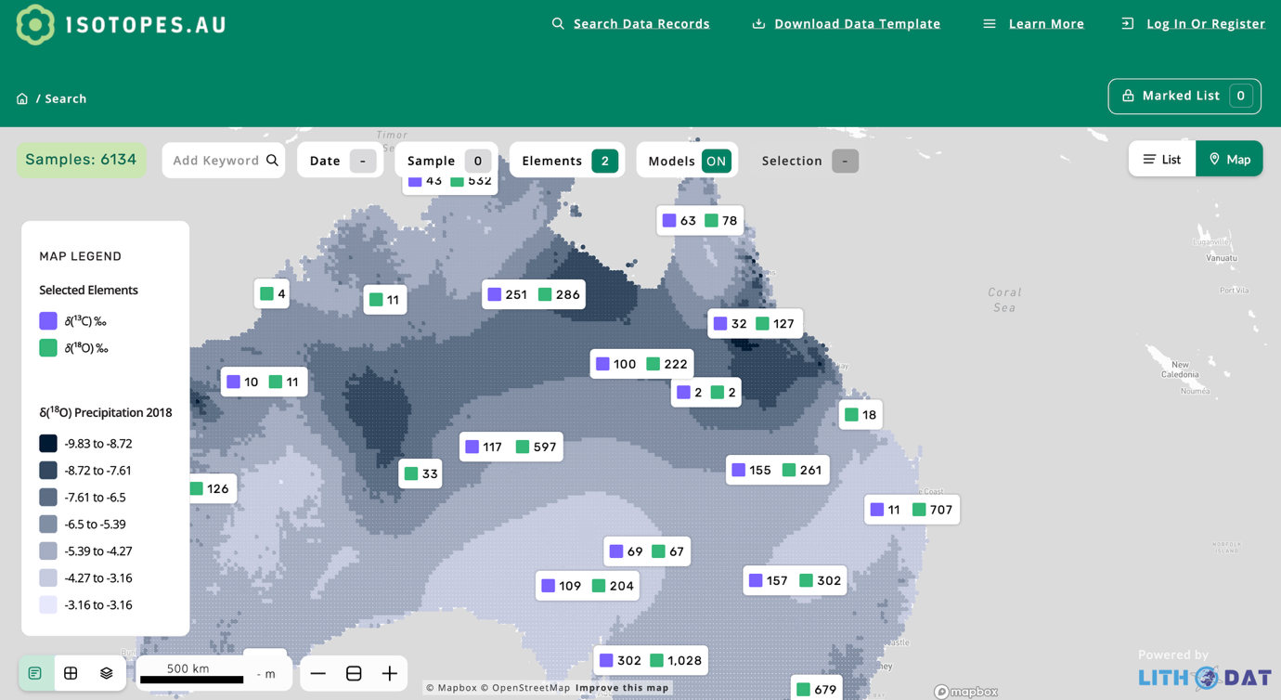
Figure 3: Real-time analytics dashboard showing platform usage metrics, data ingestion statistics, and quality control monitoring across all institutional data sources.

6. Publications
The Isotopes.au project has produced multiple peer-reviewed publications demonstrating scientific rigor and international recognition:
- Welti, N., Noble, W., Fraser, G., Flick, L., Gerber, C., Hawkins, S., et al. (2025). Harmonizing Stable Isotope Data in Australia: The isotopes.au Platform for Enhanced Data Sharing and Collaboration. EGU General Assembly 2025, Vienna. https://doi.org/10.5194/egusphere-egu25-14534
- Welti, N., Crawford, J., Fraser, G., Flick, L., Gerber, C., Hawkins, S., et al. (2024). Federating Stable Isotope Data to Create a National Asset in Australia. 13th International Conference on the Application of Stable Isotope Techniques in Ecological Studies, Fredericton, Canada.
- Flick, L., Crawford, J., Fraser, G., Gerber, C., Hawkins, S., Hughes, C., et al. (2024). A Common Ontology for Stable Isotope Data. 13th International Conference on the Application of Stable Isotope Techniques in Ecological Studies, Fredericton, Canada. http://hdl.handle.net/102.100.100/636851?index=1
For verification of project performance and technical details, contact:
Dr. Nina Welti
CSIRO – Environmental Isotopes Laboratory
Waite Campus
Email: nina.welti@csiro.au
Partners: CSIRO, Geoscience Australia, ANSTO, NMI, ARDC
Funding: Australian Research Data Commons (ARDC) + CSIRO co-funding

